an in-depth online course on the practical and legal asepects of The WTO DISPUTE SETTLEMENT

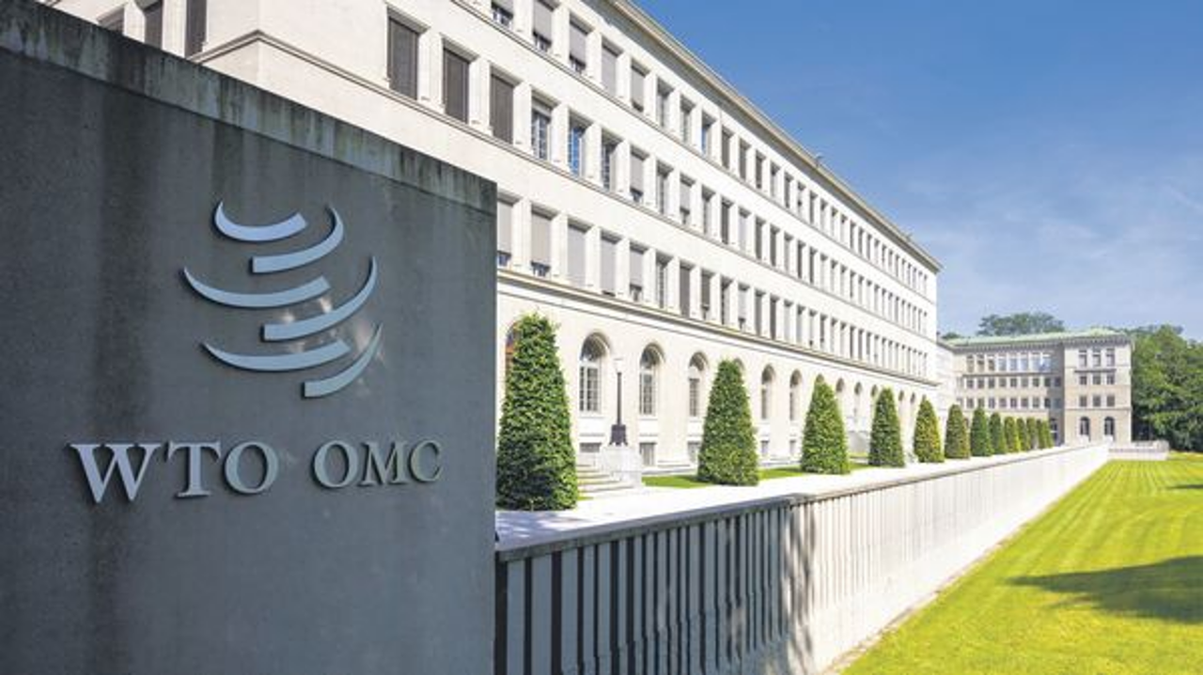

Course Overview and Design

The 2025 In-Depth Dispute Settlement Course is organised by the WTO Secretariat to provide Members' government officials with a robust understanding of WTO dispute settlement procedures, knowledge of the practical aspects of dispute settlement, and the legal underpinnings of the dispute settlement system. This advanced course combines lectures, round-table discussions, theoretical insights, and practical exercises, equipping participants with both strategic knowledge and applied skills essential for navigating WTO dispute settlement.

The course has been designed by Marisa Beth Goldstein, Senior Counsellor with the WTO Legal Affairs Division (LAD), and Gerard Penalosa, Paralegal with LAD, ensuring a curriculum that reflects the latest developments and practicalities of WTO litigation. In addition to the core team supporting the course, participants will interact with legal experts from the Secretariat, seasoned government officials, respected private legal practitioners, and academics. Their diverse and extensive experience ensure that participants gain comprehensive insights into the intricacies of WTO dispute settlement litigation from a variety of perspectives. Participants will be divided into small groups with each group having a "tutor" from the WTO Secretariat with whom they can communicate and ask questions between the sessions. Gerard and our colleague, Susana Arencibia Gonzalez from ITTC will also be on hand to assist the participants with any logistical issues relating to course participation.

Biographies of the speakers are included in the programme, allowing participants to familiarise themselves with the expertise and backgrounds of each presenter.

The virtual programme includes webinar sessions at set times for all participants, "breakout" sessions where participants can join sessions offered at differing times to reflect the global scope of the course (these sessions will be recorded and available to all participants after they occur), and asynchronous trainings and exercises that can be done on their own schedule.

The course will take place over four weeks with a minimum commitment of 5 "live" hours per week, spread over three different sessions. The programme will take place in the weeks of 1 and 8 December 2025 and 12 and 19 January 2026. This will give participants time to absorb the first part of the course, complete asynchronous assignments, and have a restful transition from 2025 to 2026 before returning to the course.

The course will focus on four themes:

First, logistical and practical information on handling disputes: Under this area, the course will help participants acquire knowledge on how to handle notifications to the DSB, proper form for consultations and panel requests, organisational issues (such as panel composition, working procedures, and timetables), procedures for filing documents through the Dispute Settlement Registry, confidentiality of dispute documents, ensuring submissions and documents follow WTO editorial standards, and how to find dispute settlement information and documents.

Second, representation skills: Sessions address critical aspects of dispute preparation, including problem identification, evidence gathering, burden of proof and standard of review, and presenting both written and oral arguments. Best practices will be shared from complainant, respondent, and third-party perspectives. Participants will engage off-line in practical exercises relating to drafting consultations requests, panel requests, and oral statements. Participants will submit and evaluate each other's assignments in a roundtable session moderated by WTO experts fostering peer-to-peer learning.

The third theme will be after the panel: In these sessions we will examine the procedures in the DSU for implementation and suspension of concessions. We will also look at the appeal procedures in the DSU and explore how Members have employed alternative mechanisms to resolve disputes amidst ongoing negotiations on dispute settlement reform. Speakers with first-hand experience will discuss the use of an alternative appeal process under Article 25 of the Dispute Settlement Understanding (DSU). Participants will then engage in practical exercises examining a complex dispute with multiple phases (EC – Bananas) and a simulation of a DSB meeting.

The final theme will be focused on reform of the DSU participants will be introduced to the state of the ongoing discussions and be invited to present their own proposals for DS reform as we move towards MC14 in Yaoundé.

This in-depth course is a unique opportunity for officials to develop practical and legal knowledge in WTO dispute settlement while also developing general litigation and research skills, with instruction from leading professionals across the WTO Secretariat, private practice, government, and academia, ensuring participants leave well-prepared to engage in or advise on WTO dispute settlement litigation with confidence and competence.

_______________

