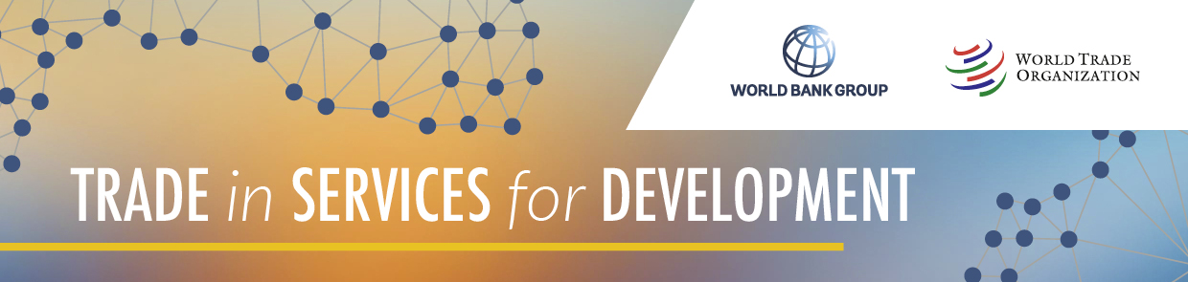

**National Workshop for the Philippines on Trade in Services for Development**

**13-16 October 2025**

*The WTO Secretariat will conduct a national workshop in the Philippines on trade in services.  Falling under the Trade in Services for Development (TS4D) initiative, the workshop will aim to increase knowledge about key trends in trade in services and, in particular, the contribution of services trade and services trade policies for developing countries, and the supporting role of the GATS in that regard.*

*The workshop will aim to set the foundations for an assessment by officials and stakeholders of the Philippines' services trade and related policies, with the assistance of tools being developed or expanded in the context of the joint WTO-World Bank work program under the TS4D initiative.  Key trends in services trade will be underscored through use of the Global Services Trade Data Hub.  A draft list of core measures, extracted from the WTO-WBG Services Trade Policy Database, will be reviewed and discussed by participants, and its potential uses explored. The WTO-WBG Services Trade Restrictiveness Index (STRI) will be used to situate the Philippines' services trade policies in key sectors.  The WTO-WBG services trade competitiveness checklist will be presented, and participants, in that light, will engage in a discussion of the Philippines' strengths and weaknesses, as well as priority areas and key objectives on services trade and related policies.  The WTO-WBG Services Domestic Regulation Self-Assessment Questionnaire will be presented, as a tool for participants to benchmark the Philippines' alignment with good regulatory practices for trade in services.*

**Programme**

|  |  |  |
| --- | --- | --- |
| **Monday, 13 October 2025** | | |
|  | **Opening session**  Welcome and introductory remarks | National Authorities  & WTO |
|  | **Overview: Trade in Services for Development Initiative** | WTO |
| 9:30 – 11:00 | **Global and regional trends on trade in services**  This session will review key trends in global trade in services, including for developing countries, as well as regional trends.  This session will also include a demo on available services statistics and an interactive exercise. | WTO |
| 11:00 – 12:00 | **The Changing Contribution of Services Trade to Development** | WTO |
| 12:00– 13:00 | LUNCH BREAK |  |
| 13:00 – 14:30 | **Review of GATS and its main obligations**  The presentation will focus and discuss in depth the scope of the GATS, present its main obligations and disciplines, as well as the structure of specific commitments. | WTO |
| 14:30 – 17:00 | **Scheduling Approaches in the GATS and regional trade agreements on services**  This session would discuss the scheduling approaches used in international trade agreements on services. It will explain key concepts underlying of the positive- and negative-list approaches, and discuss key differences and implications. | WTO |

| **Tuesday, 14 October 2025** | | |
| --- | --- | --- |
|  | **I-TIP Services & Practical Exercise on Services Trade Policies**  Participants will be familiarized with the contents of I-TIP services, with a particular focus on the Services Trade Policy Database (STPD), the Services Trade Restrictions Index (STRI) and the STRI visualization tool.  An interactive exercise will be conducted to analyse services trade policies. | WTO |
|  | **Presentation of the TS4D Transparency initiative**  **Discussion of the Philippines draft list of measures, extracted from I-TIP Services** | WTO  All participants |
| 12:00 - 12:45 | LUNCH BREAK |  |
|  | **Presentation of the TS4D Services Trade Competitiveness Checklist** |  |
|  | **Group Exercise – Applying the Services Trade Competitiveness Checklist to the Philippines**   * Identifying competitive strengths and weaknesses * Identifying priority areas for domestic policy improvements * Highlighting overarching principles and expected contribution and strategic considerations for services trade policies in the Philippines. | All participants |

| **Wednesday, 15 October 2025** | | |
| --- | --- | --- |
|  | **Group Exercise – Applying the Services Trade Competitiveness Checklist to the Philippines (continued)** | All participants |
|  | **The GATS and Regulation**   * The relationship between GATS Articles XVI, XVII, XVIII and Article VI * Existing regulatory obligations in GATS Article VI:1-3 & 6 * Multilateral and Plurilateral negotiations in the WTO * The New Disciplines on Services Domestic Regulation * Research on the prevalence of domestic regulation disciplines in regional trade agreements & economic benefits from implementation | WTO |
| 12:00 - 12:45 | LUNCH BREAK |  |
|  | **Exercise on Domestic Regulation**   * Group exercise: assessment of compatibility of regulatory measures with the GATS and the SDR Reference Paper. | All participants |
|  | **The WB/WTO Handbook on GRPs to facilitate Services Trade**   * Overview and main findings of the Handbook * Group exercise on the use of the the Self-Assessment questionnaire | WTO |
|  | **Evaluation & Closing Session** |  |

| **Thursday, 16 October 2025** | | |
| --- | --- | --- |
|  | **Consultations and small group meetings organized by the Ministry** | WTO |