E
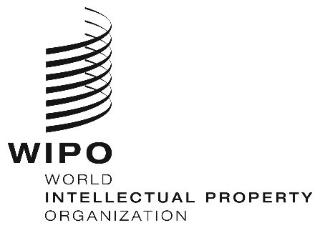

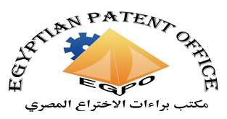

EGYPTIAN PATENT OFFICE

SUB-REGIONAL MEETING

WIPO/ ORIGINAL: ENGLISH
DATE: January 14, 2020

Sub-regional Meeting on Intellectual Property, Innovation and Public Health for Selected Arab Countries

organized by
the World Intellectual Property Organization (WIPO)

in cooperation with
the Egyptian Patent Office (EgPO)

Cairo, Egypt, April 21 to 23, 2020

PROVISIONAL PROGRAM

prepared by the International Bureau of WIPO

Tuesday, April 21, 2020

9.30 – 10.00 Opening addresses by:

The Representative of the World Intellectual Property Organization (WIPO), Geneva

The Representative of the Egyptian Patent Office (EgPO), Cairo

10.00 – 10.30 Topic 1 Mapping the Interface Between Health and Intellectual
Property (IP):

Speaker: WIPO Speaker

WTO Speaker

10.30 – 10.45 Discussion

10.45 – 11.15 Topic 2 The IP System as Determinant for Innovation in the Medical
Technologies Sector

Speaker: External Speaker

11.15 – 11.30 Discussion

11.30 – 12.00 Coffee Break

12.00 – 12.30 Topic 3 The Public Health Context: Overview and Determinant of
Access

Speaker: WIPO Speaker

WTO Speaker

12.30 – 12.45 Discussion

12.45 – 13.15 Topic 4 Access to Health-Related Goods and Services

Speaker: External Speaker

WTO Speaker

13.15 – 13.30 Discussion

13.30 – 14.00 Topic 5 Innovation and Access to Medicine – Regional Perspective

Speaker: A Representative from Egypt

14.00 – 14.15 Discussion

Wednesday, April 22, 2020

10.00 – 10.30 Topic 6 Using the IP System and Its Policy Options to Support
Access to Medical Technologies

Speaker: WIPO Speaker
WTO Speaker
10.30 – 10.45 Discussion

10.45 – 11.15 Topic 7 The Doha Declaration on the Agreement on Trade-Related
Aspects of Intellectual Property Rights (TRIPS Agreement) and Public Health

Speaker: External Speaker

WTO Speaker

11.15 – 11.30 Discussion

11.30 – 12.00 Coffee Break

12.00 – 12.30 Topic 8 Effective Use of the IP System to Foster Pharmaceutical
Innovation

Speaker: WIPO Speaker

WTO Speaker

12.30 – 12.45 Discussion

12.45 – 13.15 Topic 9 TRIPS Flexibilities in the Pharmaceutical Field

Speaker: WIPO Speaker

WTO Speaker

13.15 – 13.30 Discussion

13.30 – 14.00 Topic 10 Compulsory Licenses for Export: A Procurement Tool for
Medicines

Speakers: External Speaker
A Speaker from the Region

WTO Speaker

14.00 – 14.15 Discussion

Thursday, April 23, 2020

10.00 – 10.30 Topic 11 Pharmaceutical Industry Policy, Local Production of
Medicine, Technology Transfer and Access Strategies

Speaker: WIPO Speaker

10.30 – 10.45 Discussion

10.45 – 11.15 Topic 12 WIPO Re:Search

Speaker: WIPO Speaker

11.15 – 11.30 Discussion

11.30 – 12.00 Coffee Break

12.00 – 12.30 Topic 13 Health-Related Provisions in Bilateral and Regional Trade
Agreements

Speakers: External Speaker
A Speaker from the Region

WTO Speaker

12.30 – 12.45 Discussion

12.45 – 14.00 Topic 14 Sharing Views and Experiences: What Is Needed to Foster
Innovation and Access in the Pharmaceutical Sector

Speakers: All Participants

14.00 – 14.30 Closing Session

[End of document]

