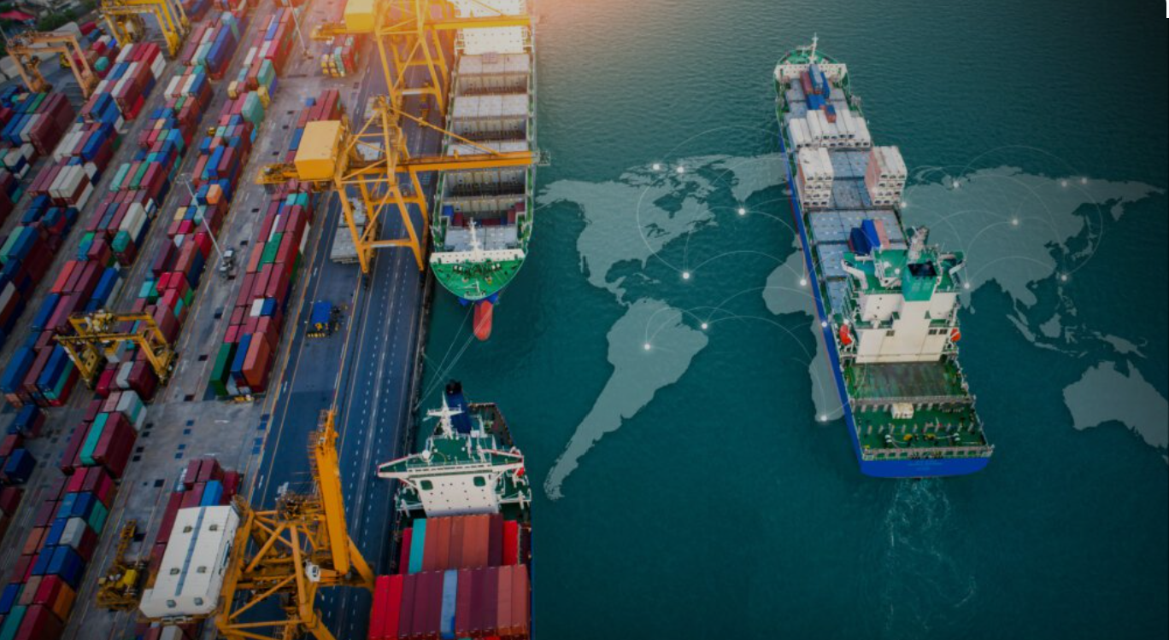
Trade
TRADE FINANCE WORKSHOP FOR BANKS AND SME’S
Saint Kitts and Nevis, East Caribbean
November 26-28, 2025

AGENDA

Knowledge sharing on (i) exploring a range of trade finance instruments to boost cross-border and inter-regional trade flows, (ii) enhancing access to trade finance for Small and Medium Enterprises (SMEs) (iii) strengthening measures to combat Trade-Based Money Laundering (TBML) while promoting expansion in correspondent banking network

VENUE: The ECCB Auditorium

DAY 1 (November 26)
- Regional and global insights into trade finance
- Identifying market gaps in SME access to trade finance
- Trade Finance instruments, payment methods, tools and solutions for SMEs

Time | Themes & Flow | Session # | Session | Audience | Presenter
8:15 - 9:00 |  |  | Registration of participants | All Participants | IFC, WTO, OECS
9:00 - 9:30 | High Level Greetings | #1 | Opening Remarks from the Organizers | All Participants | Nikolas/Makiko- IFC; Marc Auboin - WTO; ... OECS
9:30- 10:15 | Global/Regional Insights and Market Gaps: Why is Trade Finance (TF) important for trade in OECS countries? | #2 | International and Regional Trade Financing for SME’s:  Overview I. Supply and Demand of International Trade Finance on a global level and in East Caribbean. | All Participants | Marc Auboin - WTO
10:15 – 10:30 |  |  | Coffee break
10:30 – 11:15 | Global/Regional Insights and Market Gaps: Why is Trade Finance (TF) important for trade in OECS countries? | #3 | International and Regional Trade Financing for SME’s:  Overview II. SME Finance:  Summary of Research. Testimonials from banks and SMEs in East Caribbean. inspirational videos-IFC | All Participants | Roberta Allport - WTO; Susanne Kavelaar -IFC
11:15 -12:30 | Unlocking Regional and Global Trade: Practical Trade Finance Tools for Caribbean Growth | #4 | Trade Finance Tools  How banks and SMEs can leverage modern trade finance instruments to expand export/import capacity, improve cash flow, and manage risk in the Eastern Caribbean market. | All Participants | Marc Auboin - WTO
12:30 -13:30 |  |  | Lunch
13:30 -15:00 | Trade Finance addressing the Market Gaps:  Availability and use of (advanced) trade finance serving SMEs and Financial Institutions | #5 | Summary/Refresher of payment methods, trade financial instruments, advanced trade finance. Exchange of Experiences among participants.  What challenges and risk are you facing in your import /export business?  Which payment terms are available? Which options are there for short-term working capital and trade finance solutions, with a focus on SMEs? | All Participants | Margaret Makura- IFC
15:00 -15:30 |  |  | Coffee break / SMEs presenting their merchandises
15:30 -16:30 | Training: Tools and solutions for SMEs in trade finance | #6 | Deep Dive Trade Finance Options for importing or exporting SMEs to secure (i) delivery and (ii) payment of cross-border trade flows.  Including Design of Contracts, Documents, Incoterms, Payment terms deep dive, financial instruments including Factoring, Structured trade finance. Secure transactions and moveable properties  Real examples. | All Participants | Margaret Makura- IFC
 |  |  | End of Day 1

DAY 2 (November 27)

- Speed-Networking: SMEs present business needs, Banks outline financing options
- Working Capital Management for SMEs, Financial Management and Business Plan (Audience: SMEs)
- Trade Based Money Laundering (TBML), Correspondent Banking, Global Trade Finance Program (Audience: Banks)

Time | Themes & Flow | Session # | Session | Audience | Presenter
8:30 - 9:00 |  |  | Recap Day One, Session #6 | All participants | Margaret Makura- IFC
9:00 – 10:30 | Local Perspective: Speed Networking Sessions | #7 | Identifying Key Challenges:  - A discussion on Financing Obstacles as Perceived by SMEs and Participating Banks  - What Do SMEs need? What do Banks have to offer?  - Understanding Rejection Rates and their root causes  - Analyzing potential mitigation measures | All Participants | Mehdi Chahed- IFC  Roberta Allport- WTO  Susanne Kavelaar - IFC
10:30 -10:45 |  |  | Coffee break
10:45 – 11:30 | Wrap up: Speed Networking Sessions | #8 | Wrap-up of the Speed Networking Sessions with remarks from audience and volunteers | All Participants | Mehdi Chahed- IFC  Roberta Allport- WTO  Susanne Kavelaar - IFC
SEPARATE SIMULTANEOUS SESSIONS FOR SME’S AND BANKS
11:30 -13:00 | Training: Working Capital Management | #9 | Interactive SME module I:  Working Capital Management for SME’s: Important as an alternative to counter lack of collaterals, guarantees, ownership | SMEs | Mehdi Chahed- IFC
11:30 -13:00 | Training: Knowledge and tools to address TBML | #10 | Introduction to Trade Based Money Laundering (TBML), Controls to Prevent TBML and Red Flags  Case Studies | Banks- Compliance, Risk, Audit, Front and Sales Offices Trade Finance | Marc Auboin - WTO Susanne Kavelaar – IFC
13:00 -14:00 |  |  | Lunch
14:00 – 15:00 | Training: Working Capital Management | #11 | Interactive SME module II  Loan/Financial Management for SMEs: (i) Refresher on principles (ii) Best practices | SMEs | Mehdi Chahed- IFC
14:00 - 15:00 | Roundtable around Correspondent Banking Network | #12 | Round table with Correspondents Banks (TBD)  Q&A session | Banks- Compliance, Risk, Audit, Front and Sales Offices Trade Finance | Correspondent Bank
15:00 -15:15 |  |  | Coffee break
15:15 -16:15 | Developments in the credit ecosystem | #13 | - Opportunities for business finance (Securities Commission)  - Partial credit guarantee scheme (PCG corporation)  - Modernization of the payments system | All Participants | ECCB
16:15-18:30 | Optional Cocktail for Either Day 2 or Day 3
End of Day 2

DAY 3 (November 28)

- Technological innovation as a catalyst of Trade Finance Improvement
- Transactional Trade Finance and Supply Chain Finance
- Export Credit Agencies and Business Development Associations

Time | Themes & Flow | Session # | Session | Audience | Presenter
08:30 -09:45 | Interactive case study on SME trade finance | #14 | Analysing two different financing options based on real-world scenarios | All Participants | Margaret Makura- IFC
09:45 -10:00 |  |  | Coffee break
SEPARATE SIMULTANEOUS SESSIONS FOR SME’S AND BANKS
10:00 -11:45 | Training: strategies to tackle existing market and industry challenges | #15 | Interactive SME module III: How to come up with a suitable business plan to achieve a successful application for a loan | SMEs | Mehdi Chahed- IFC
10:00 -11:45 | Overview of Cutting-Edge Trade Finance Structures:  SCF  Climate Smart Trade Finance  Gender Finance | #16 | Daily Transactional Trade Finance and Supply Chain Finance: Overviews, including  - IFC Global Trade Finance Program (GTFP) including sustainable trade finance  - A review of Supply Chain Finance (SCF) principles, their role in shaping SCF programs and technology platforms | Banks - CEO, General Manager, SME/Business Banking Manager,  Supply Chain Finance Director, Commercial Director | Susanne Kavelaar -IFC, Manuel Blanco-IFC
11:45 -12:45 | The Role of Export Credit Agencies and Business Development Associations in Facilitating Global Trade and Investment | #17 | Overview of instruments  Impact on exporters and international buyers  How SMEs can engage with these corporations  Success stories of the engaged importers/exporters | All Participants | Caribbean Dev Bank/ CARICOM/ Afreximbank
12:45 -13:34 |  |  | Lunch
13:45 – 15:00 | Addressing Market Gaps with Trade Products: Framework, Trends, and Utilization by Cross-Border SMEs | #18 | Digital Innovations in Trade Finance:  Exploring the impact of digitization in trade finance, covering areas such as e-commerce, digital wallets, and the application of blockchain technology | All Participants | Margaret Makura- IFC
15:00 -15:15 |  |  | Coffee break
15:15 – 15:45 | Takeaways and Closing Remarks | #19 | Wrap Up, conclusions and next steps | All Participants | IFC, WTO, OECS
15:45 – 16:30 |  |  | Completion of the survey, group photo session and delivery of the certificates | All Participants | Susanne Kavelaar -IFC, Manuel Blanco-IFC
16:30 - 18:30 | Optional Cocktail for Either Day 2 or Day 3
End of Day 3

