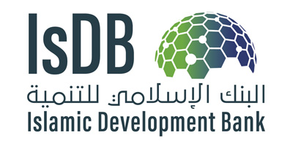 | 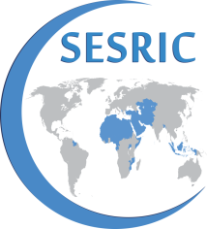 | 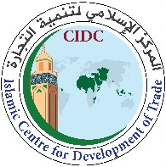

VIRTUAL TRAINING WORKSHOP ON DATA COLLECTION AND ANALYSIS OF TRADE IN SERVICES AMONG THE OIC MEMBER STATES
March 23rd 25th, 2021

PROGRAMME

GMT+1 23 March 2021
09.00 - 9.30: Opening Ceremony
- Speech of Mrs. Latifa Elbouabdellaoui, Director General of the Islamic Centre for Development of Trade (ICDT)
- Speech of Dr. Nebil Dabur, Director General of the Statistical, Economic and Social Research and Training Centre for Islamic Countries (SESRIC)
- Speech of the Representative of the Country Strategy and Cooperation Department of IsDB (CSCD)
- Photo of participants

9.30- 11.00: Session 1: Importance of Trade in Services Statistics and relevant Classifications
Chairperson: Dr. Kenan BAGCI, SESRIC
- Importance of trade in services statistics for trade negotiations, and the Manual of Statistics on International Trade in Services (MSITS 2010), Mrs. Barbara D'Andrea (WTO)
- Relevant classifications of trade in services –EBOPS 2010, ICFA Rev.1,W/120, Mr. Steve MacFeely/Mrs. Sanja Blazevic (UNCTAD)
- Compiling a global dataset on trade in services, overview of other data sources on trade in services, and data gaps in OIC members, Mr. Christophe Durand (ITC)
11.00-11.15: Break
11:15 – 11:45 Debate on Session 1
11.45 – 13.00: Session 2: Experiences of Regional Institutions on Data Collection of Trade in Services
Chairperson: Mr. Mamoudou SALL, ICDT
Panellists:
- Experience of African Union within the framework of ZLECAf on trade services data collection, ECA
- Experience of League of Arab States on trade services data collection
- Experience of SESRIC on data collection in trade in services by Dr. Atilla KARAMAN
- Debate

GMT+1 24 March 2021
9.00 – 10.00: Session 3: Challenges in measuring trade in services
Chairperson: Representative of ITC
- Collecting trade in services statistics in practice, Mr. Steve MacFeely (UNCTAD)
- ITC survey on non-tariff measures in services, Ms Ursula Hermelink (ITC)
10.00 – 10.15: Break

10:15-12:00 Session 4: Experiences of OIC Member Countries on Trade in Services Data Collection and Analysis
Chairperson: Representative of IsDB
Panellists:
- Morocco
- Malaysia
- Egypt
- Senegal
- Turkey
- Uganda
- Saudi Arabia
- Pakistan
Debate
GMT+1 25 March 2021
9.00 – 11.00: Session 5: Trade in Services Data Analysis
Chairperson: Representative of WTO
Panellists: (WTO, UNCTAD, ITC, UNSD video, ICDT)
- - The Trade in Services by Mode of Supply dataset (TISMOS) and the WTO-OECD Balanced Trade in Services Dataset (BaTIS), Mr. Steen Wettstein (WTO)
- - Introduction to e-learning courses on trade in services statistics, Mr. Dominique Chantrel/Mr. Mark Assaf (UNCTAD)
- - Export potential, Ms. Julia Seiermann (ITC)
- - Measuring digital services, Mr. Torbjörn Fredriksson (UNCTAD) and Mrs. Barbara D'Andrea (WTO)
- - Creative services, Mr. David Bicchetti, UNCTAD
- - OIC Trade in services data analysis, Mr. Mamoudou SALL, ICDT
- - The importance of the Business Register, (UNSD video recording)

- 11.00 – 11.15: Break
11.15 – 12.00: Round Table/ Interactive Discussion: Strategies of collaboration on trade in services data collection and analysis in the OIC Member Countries
12.00 - 12.30: Closing Session:
- Compilation of key recommendations
- Distribution of Certificates of Participation
- Closing remarks: SESRIC, IsDB and ICDT

