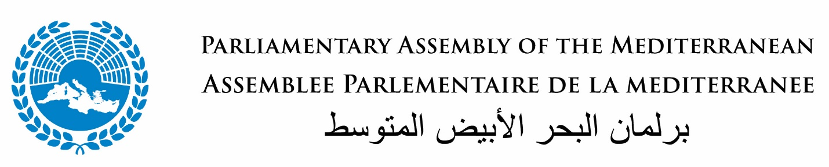

PAM Euro-Mediterranean and Gulf Economic Forum
7-8 December 2022, Marrakesh, Morocco
Kindly hosted by the House of Councillors of the Kingdom of Morocco
PRELIMINARY AGENDA (as of 28 October 2022)

DAY 1

09:00 -10:00 | Registration of Participants
10.15 Delegates seated in the room
10.30 – 13.00 | High-level Opening Ceremony
13.00-14.00 Light Lunch
14.00 – 16.00 | Plenary Session 1:  “The Euro-Mediterranean and Gulf Economic Zone”. A more financially and commercially integrated region and the role of the private sector
16.00-18.00 | Plenary Session 2:  (Room A)  Threats to energy security – ensuring affordable supply, while embracing the Green Transition and the SDGs in the fight against Climate Change
19.00 | Official Dinner Hosted by the House of Councilors of the Kingdom of Morocco

DAY 2
08.30 – 9.30 | Plenary Session 3:  Food insecurity: the Euro Med and GCC Regions - what role for Governments, the Private Sector, Trade and Investments?
9.30-10.30 | Thematic Session:  Fighting Inequalities: regional and international solutions for empowering women and youth
10.30-11.30 | Thematic Session:  Overcoming Bottlenecks and the Digital Divide: How can Logistics, AI, Trade and Investment facilitation measures contribute
11.30-12.30 | Thematic Session:  Best and more Sustainable Practices to Relaunch the Tourism Sector
13.00-14.00 Light Lunch
14.30- 16.00 | Conclusions by Moderators of each Thematic Session
16.00-16.30 | Reading of the Recommendations of the Forum by the PAM Presidency
17.00-19.00 Cultural program
Dinner
CLOSE OF DAY 2

