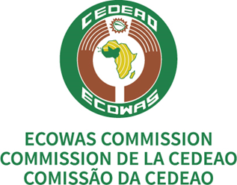

FIRST (1ST) REGIONAL MEETING ON THE AFCFTA DISPUTE SETTLEMENT MECHANISM
Virtual. 23 – 24 March 2022

Draft Agenda
Opening Session

Election of Bureau and Consideration of Agenda

Item 1 | Presentation of WTO - Dispute Settlement Body (DSB)
Item 2 | Presentation and Consideration of Trade and Trade-Related Dispute Settlement Landscape in the Region  - ECOWAS Courts of Justice  - ECOWAS Commission  - Selected Country presentations (??)
Item 3 | Presentation and Consideration of the Update on AfCFTA Dispute Settlement Mechanism
Consideration and Adoption of Report

Closing Session

FIRST (1ST) REGIONAL MEETING ON THE AFCFTA DISPUTE SETTLEMENT MECHANISM
Virtual. 23 – 24 March 2022

Draft Work Programme

Day 1: GMT
08:30 – 09:00 | Platform opened for connection
09:00 - 09:20 | Opening Session  - ECOWAS  - Ghana
09:20 – 09:30 | Election of Bureau and Consideration of Agenda
09:30 – 13:00 | Item 1: Presentation of WTO - Dispute Settlement Body (DSB)  Presentation by WTO followed by Discussions
13:00 – 14:00 | Break
14:00 – 15:30 | Item 2: Presentation and Consideration of Trade and Trade-Related Dispute Settlement Landscape in the Region  Presentation by ECOWAS followed by Discussions
15:30 – 17:00 | Item 3: Presentation and Consideration of the Update on AfCFTA Dispute Settlement Mechanism  Presentation by AfCFTA/ECOWAS followed by Discussions
Day 2: GMT
09:00 – 13:00 | Item 3: Presentation and Consideration of the Update on AfCFTA Dispute Settlement Mechanism (cont’)
13:00 – 14:00 | Break
14:00 – 14:30 | Consideration and Adoption of Report
14:30 – 15:00 | Closing

