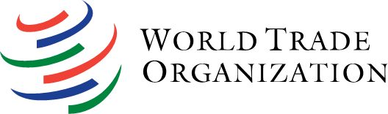
VIRTUAL WTO WORKSHOP FOR BELARUS ON THE WTO SPS AND TF AGREEMENTS

30 November – 4 December 2020

DRAFT PROGRAMME
(draft 12 Nov)

MODULE 1 - OVERVIEW SPS AGREEMENT AND COMMITTEE
Date/time: 30 Nov (Mon): 11:00 – 13:00 (Minsk time) // 9:00 – 11:00 (Geneva time)

- Welcome/opening by Belarus (aprox. 15 min)
  - TBC – rep. TBC
- Intro SPS principles/obligations (45 min)
  - Presentation Mr Rolando Alcala, Agriculture and Commodities Division, WTO Secretariat (30 min)
  - Q&As with Participants (15 min)
- Intro work of the SPS Committee (45 min)
  - Presentation Mr Rolando Alcala (30 min)
  - Q&As with participants (15 min)
- Wrap-up/final Q&As (10 min)

MODULE 2 – SPS Agreement and Annex C
Date/time: 2 Dec (Wed): 11:00 – 13:00 (Minsk time) // 9:00 – 11:00 (Geneva time)

- Welcome/opening by Belarus (10 min)
  - TBC – rep. TBC
- SPS Agreement and Annex C/provisions (1h 45 min)
  - SPS Agreement and Annex C/provisions
  - The SPS Agreement: Linkages with TFA
  - eCertification
    - Presentations (1h 30 min):
      - Mr Rolando Alcalá, Agriculture and Commodities Division, WTO Secretariat
      - Mr Simón Padilla, Standards and Trade Development Facility (STDF)
    - Q&As with Participants (15 min)
- Wrap-up/final Q&As (15 min)

MODULE 3 – TFA and Transit
Date/time: 4 Dec (Thu): 11:00 – 13:00 (Minsk time) // 9:00 – 11:00 (Geneva time)

- Welcome/opening by Belarus (aprox. 10 min)
  - TBC – rep. TBC
- Intro TFA principles/obligations (60 min)
  - Presentation Mr Mark Henderson, Market Access Division, WTO Secretariat (45 min)
  - Q&As with Participants (15 min)
- Intro Article 11. Transit (30 min)
  - Presentation Mr Mark Henderson (15 min)
  - Q&As with participants (15 min)
- Wrap-up/final Q&As (10 min)

__________

